JobSeeker Technical Documentation: Low-AI-Cost Design on Supabase
Oct 13, 2026 · @Dhon

1. Overview
JobSeeker now runs on Supabase and uses AI in only four narrow places, so most features cost nothing per use. Everything else is handled by database rules, curated content and SQL.
This document replaces the AI-heavy design in the proposal report. It describes what is AI-free, what still calls a model, how Supabase hosts each piece, and how to cap spending.
Design principles
- Rules first, AI last. If a template, a formula or a SQL query can do the job, no model is called.
- Generate once, reuse many times. Role roadmaps, interview questions and resources are written once and stored, then shared by every user.
- AI is opt-in and metered. The user presses a button for an AI result; every call is counted against a quota.
- Small input, small output. Send only the fields needed, cap output length, and use the cheapest model tier that passes your tests.
- The user confirms. AI suggestions never change the plan automatically, which also prevents wasted retries.
Backend: Supabase
Need | Supabase service
Database for users, plans, tasks, content | Postgres
Login (email, Google) | Supabase Auth
Per-user data protection | Row Level Security (RLS)
Planner logic, AI gateway, job import | Edge Functions (Deno/TypeScript)
Nightly rescheduling and reminders | pg_cron with pg_net
CV PDF files | Storage
Live chat updates (optional) | Realtime

2. Where AI is used and where it is not
Only four actions call a model: custom-role roadmaps, interview answer feedback, CV wording help and free-text coach chat. All of them are capped per user.
Feature | How it works now | Model call? | Limit
Roadmap for common jobs | Pre-written role templates in the database, adjusted by rules to the user's deadline | No | None
Roadmap for a job not in the library | One AI call builds a template, saved and reused for the next user with that job | Yes, once per new role | 1 per user per week
Daily and weekly tasks | Scheduling algorithm in SQL/Edge Function | No | None
Skill-gap view | Compare user skills with role skills in SQL | No | None
Resources | Curated table with tags, searched by Postgres full-text search | No | None
Coach quick actions ("I'm behind", "Finished early", "Pause a week") | Buttons call the planner directly | No | None
Coach free-text chat | Model answers with a short context summary | Yes | Weekly message cap
Mock interview questions | Question bank in the database | No | None
Mock interview feedback | Keyword and rubric checklist scores the answer for free; AI feedback only on request | Optional | Weekly cap
CV building | Form wizard fills a template locally | No | None
CV "Improve wording" | One AI call per section, on button press | Optional | Weekly cap
Job matching | Skill-overlap score in SQL against stored vacancies | No | None
Vacancy import | Scheduled job reads public feeds or manually curated entries | No | None
Why this works. The expensive part of the old design was calling a model for every plan change, every interview answer and every job ranking. Those are repeatable decisions, so they now run on fixed rules and stored data.

3. Architecture on Supabase
The web app talks only to Supabase, and just one function, ai-gateway, ever reaches the model provider.
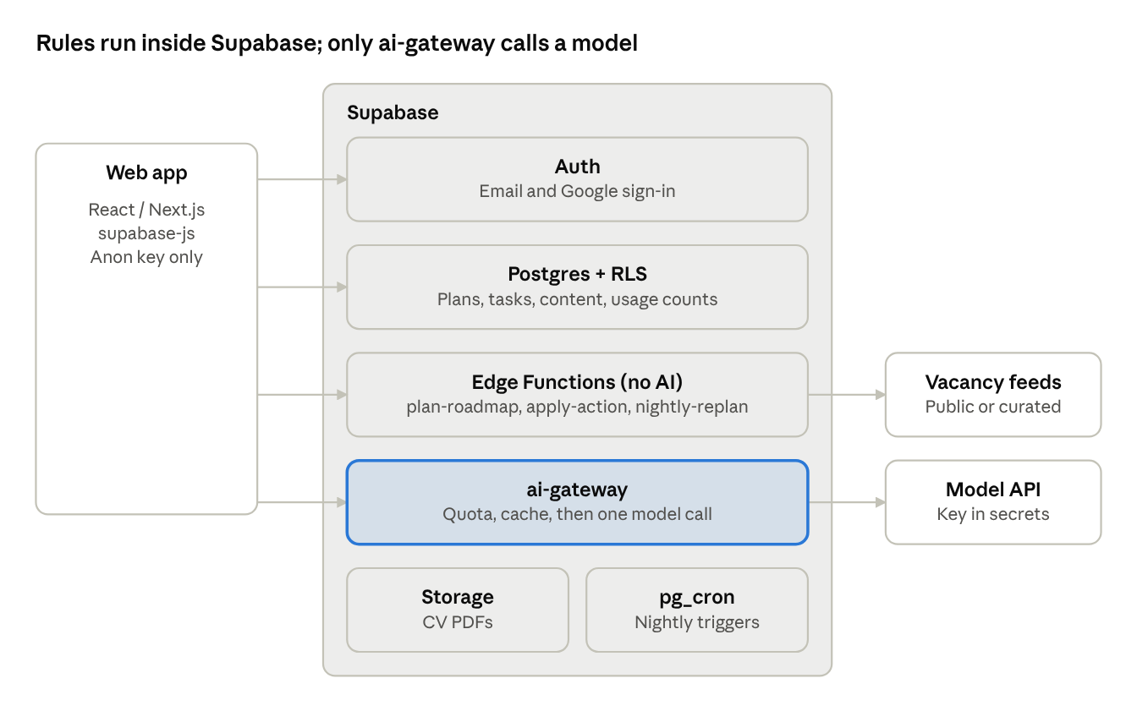
system architecture · web app, Supabase services, 2 external services
The app reads and writes ordinary data straight to Postgres, where RLS protects each user's rows. Planner changes go through Edge Functions, and only the highlighted ai-gateway path costs AI credits.

4. Database schema
The schema has 16 tables in three groups: shared content (written once), user data (private per user) and usage control.
Group | Tables
Shared content | roles, role_milestones, skills, resources, interview_questions, vacancies, vacancy_skills
User data | profiles, user_roadmaps, milestones, tasks, user_skills, interview_attempts, cv_documents
Usage control | ai_usage, ai_cache
Core tables in SQL (run as a migration; trim columns you do not need yet):
create table profiles (
id uuid primary key references auth.users on delete cascade,
full_name text,
plan text not null default 'free' check (plan in ('free','premium')),
daily_minutes int not null default 60,
created_at timestamptz default now()
);
create table roles (
id uuid primary key default gen_random_uuid(),
slug text unique not null, -- 'junior-web-developer'
title text not null,
source text not null default 'curated' check (source in ('curated','ai')),
created_at timestamptz default now()
);
create table role_milestones (
id uuid primary key default gen_random_uuid(),
role_id uuid references roles on delete cascade,
position int not null,
title text not null,
effort_hours int not null, -- used to split the deadline
skill_ids uuid[] default '{}'
);
create table user_roadmaps (
id uuid primary key default gen_random_uuid(),
user_id uuid references profiles on delete cascade,
role_id uuid references roles,
target_date date not null,
status text default 'active',
created_at timestamptz default now()
);
create table milestones (
id uuid primary key default gen_random_uuid(),
roadmap_id uuid references user_roadmaps on delete cascade,
user_id uuid not null,
title text not null,
position int not null,
start_date date, end_date date,
status text default 'todo' check (status in ('todo','doing','done'))
);
create table tasks (
id uuid primary key default gen_random_uuid(),
milestone_id uuid references milestones on delete cascade,
user_id uuid not null,
title text not null,
resource_id uuid,
due_date date not null,
est_minutes int default 30,
done_at timestamptz
);
create table ai_usage (
id bigint generated always as identity primary key,
user_id uuid not null,
feature text not null, -- 'coach','cv','interview','role'
tokens_in int, tokens_out int,
created_at timestamptz default now()
);
create table ai_cache (
key text primary key, -- hash of feature + normalised input
response jsonb not null,
created_at timestamptz default now()
);
create index on tasks (user_id, due_date);
create index on ai_usage (user_id, created_at);
The remaining tables (resources, interview_questions, interview_attempts, vacancies, vacancy_skills, user_skills, cv_documents, skills) follow the same pattern: a uuid key, a user_id on private tables, and text or jsonb content columns.

5. Authentication and Row Level Security
Every private table is locked to its owner with RLS, so the web app can call the database directly with the public key and no custom authorization code.
- Enable Supabase Auth with email and Google sign-in; create a profiles row on sign-up using a trigger.
- Turn on RLS for every table in the public schema.
- Give shared content read-only access to signed-in users.
- Keep the service-role key on the server only (Edge Functions), never in the frontend.
-- private data: owner only
alter table tasks enable row level security;
create policy "own tasks" on tasks
for all using (auth.uid() = user_id) with check (auth.uid() = user_id);
-- shared content: read-only for signed-in users
alter table roles enable row level security;
create policy "read roles" on roles
for select using (auth.role() = 'authenticated');
-- usage table: users can read their own rows, only the server writes
alter table ai_usage enable row level security;
create policy "read own usage" on ai_usage
for select using (auth.uid() = user_id);
-- profile created on sign-up
create function handle_new_user() returns trigger as $$
begin
insert into public.profiles (id) values (new.id);
return new;
end; $$ language plpgsql security definer;
create trigger on_auth_user_created after insert on auth.users
for each row execute function handle_new_user();
Repeat the owner policy for milestones, user_roadmaps, user_skills, interview_attempts and cv_documents. Writes to roles, role_milestones, resources, vacancies and ai_cache come only from Edge Functions using the service-role key.

6. Rule-based roadmap and planner engine
The planner splits the time between today and the target date across milestones in proportion to effort, then fills each week with tasks. It is plain code in one Edge Function (plan-roadmap), so it costs nothing per run.
Step 1: pick a template. Match the user's chosen job to a row in roles. If it exists, copy its role_milestones into the user's milestones. If not, the AI gateway creates one (section 7) and it is saved for everyone.
Step 2: allocate time. For milestone i with effort E_i hours, the weeks given to it are:
weeks_i = W \times \frac{E_i}{\sum_j E_j}
where W is the number of weeks until the target date. Skip hours for skills the user already has in user_skills, which gives a personal plan without AI.
Step 3: check feasibility. Required hours per day = total remaining effort ÷ days left. If this is more than the user's daily_minutes, show a warning with two options: move the date or drop optional milestones.
Step 4: create tasks. Each milestone is split into tasks by linked resources (one resource = one task, using its est_minutes), placed on weekdays without exceeding daily_minutes.
Step 5: re-plan on events. These triggers call the same function and need no AI:
Trigger | Action
Task missed for 2 days | Push unfinished tasks to the next free slots, shrink optional tasks
"I'm behind" button | Shift the current milestone later, compress the next optional one
"Finished early" button | Pull the next milestone forward
"Pause a week" button | Shift all dates by 7 days, warn if the target date is now unsafe
Target date edited | Re-run steps 2 to 4
Nightly job. pg_cron calls the function once a day to mark overdue tasks, re-plan affected users and queue reminders.
select cron.schedule(
'nightly-replan', '0 20 * * *', -- 20:00 UTC = 02:00 in Dhaka
$$ select net.http_post(
url := 'https://<project-ref>.supabase.co/functions/v1/nightly-replan',
headers := jsonb_build_object('Authorization','Bearer ' || '<service-role-key>')
) $$
);
Store the key in Supabase Vault rather than pasting it into the job in production.

7. AI gateway: the single door to the model
Every AI request goes through one Edge Function, ai-gateway, which refuses, serves from cache or calls the model, in that order. The model API key lives only in Supabase secrets, never in the app.
- Authenticate. Reject requests without a valid Supabase user token.
- Check the plan limit. Count the user's rows in ai_usage for this feature and period; stop with a friendly message if the quota is used.
- Check the cache. Hash the feature and the normalised input; if ai_cache has it, return it with zero cost.
- Call the model with a short prompt, a max_tokens cap and a required JSON output.
- Record usage in ai_usage and save the answer in ai_cache when it is reusable.
// supabase/functions/ai-gateway/index.ts
import { createClient } from 'npm:@supabase/supabase-js@2'
const LIMITS = { free: { coach: 15, cv: 5, interview: 5, role: 1 },
premium: { coach: 100, cv: 40, interview: 40, role: 5 } }
Deno.serve(async (req) => {
const sb = createClient(Deno.env.get('SUPABASE_URL')!, Deno.env.get('SUPABASE_SERVICE_ROLE_KEY')!)
const jwt = req.headers.get('Authorization')?.replace('Bearer ', '') ?? ''
const { data: { user } } = await sb.auth.getUser(jwt)
if (!user) return new Response('Unauthorized', { status: 401 })
const { feature, input } = await req.json()
const { data: profile } = await sb.from('profiles').select('plan').eq('id', user.id).single()
const limit = LIMITS[profile.plan][feature]
const since = new Date(); since.setUTCDate(since.getUTCDate() - 7)
const { count } = await sb.from('ai_usage').select('*', { count: 'exact', head: true })
.eq('user_id', user.id).eq('feature', feature).gte('created_at', since.toISOString())
if ((count ?? 0) >= limit) return Response.json({ error: 'limit_reached' }, { status: 429 })
const key = await sha256(feature + JSON.stringify(input).toLowerCase().trim())
const { data: hit } = await sb.from('ai_cache').select('response').eq('key', key).maybeSingle()
if (hit) return Response.json(hit.response)
const result = await callModel(feature, input) // your provider call; max_tokens set per feature
await sb.from('ai_usage').insert({ user_id: user.id, feature,
tokens_in: result.tokensIn, tokens_out: result.tokensOut })
if (feature === 'role' || feature === 'cv') await sb.from('ai_cache').insert({ key, response: result.json })
return Response.json(result.json)
})
sha256 and callModel are small helper functions you write once; callModel holds the provider-specific request. The quotas above are starting points; change them in one place.
Prompt rules that keep tokens low
Rule | Detail
Short system prompt | One paragraph per feature, stored in code, reused on every call
Send summaries, not history | Coach gets the current milestone, last 3 task results and the last 4 messages only
Fixed JSON output | Ask for specific fields so the reply is short and parseable
Cap output | Set max_tokens per feature (for example, 300 for coach, 600 for a new role template)
Cheapest capable model | Test each feature on the smallest model tier; move up only if quality fails
No retries on bad output | Validate once, fall back to the rule-based result instead of calling again

8. Feature designs with minimal AI
Coach chat. The screen shows quick-action buttons first; each calls the planner (section 6) and costs nothing. Free text goes to ai-gateway only when no button fits. The reply may include a proposed change as JSON (for example, {"action":"shift_milestone","days":7}); the app shows it as a confirmation card, and tapping Apply runs the same planner code. Chat history is stored in Postgres, and only a short summary and the last four messages are sent to the model.
Mock interviews. Questions come from interview_questions, tagged by role, round and difficulty. The free score checks the answer against a stored list of expected keywords and a structure rubric (for example, a behavioural answer should mention a situation, an action and a result), then shows a model answer written in advance. The "Get AI feedback" button is optional and capped. Weak topics become revision tasks through the planner.
CV builder. A step-by-step form collects education, projects, skills and experience into cv_documents as JSON. A template turns the JSON into a CV in the browser, and a PDF is saved to Supabase Storage. The "Improve wording" button sends one section and gets back a rewritten version for the user to accept or reject. The prompt forbids adding facts that are not in the input.
Job matching. Each vacancy has required skills in vacancy_skills. The match score is computed in SQL:
select v.id, v.title,
round(100.0 * count(*) filter (where us.skill_id is not null) / count(*)) as match_pct
from vacancies v
join vacancy_skills vs on vs.vacancy_id = v.id
left join user_skills us on us.skill_id = vs.skill_id and us.user_id = auth.uid()
group by v.id, v.title
order by match_pct desc
limit 20;
Skills enter user_skills automatically when the user completes a milestone linked to them. Missing skills are listed under each vacancy as suggested next goals. Vacancies come from a scheduled Edge Function that reads public feeds or a curated sheet; check each source's terms before importing.

9. Cost control and monitoring
Cost per user is capped by the quota table, and total spend is capped by a daily budget switch. Quotas below are suggested starting values, counted over a rolling 7 days.
Feature | Free plan | Premium plan
Coach free-text messages | 15 | 100
AI interview feedback | 5 | 40
CV "Improve wording" | 5 | 40
New custom-role roadmaps | 1 | 5
Estimating cost. Cost per call depends on your provider's current prices, which change, so fill them in from its pricing page:
cost = \text{calls} \times \left( \frac{T_{in}}{10^6} \, P_{in} + \frac{T_{out}}{10^6} \, P_{out} \right)
T is tokens per call and P is the price per million tokens. For planning, assume about 800 input and 300 output tokens for a coach message, a figure to replace with real numbers from ai_usage after the first week of testing.
Monitoring
- A SQL view sums tokens_in and tokens_out per feature per day, so you see which feature costs most.
- A app_settings row ai_enabled can be switched off to stop all calls at once; the gateway checks it first.
- A daily token budget in the gateway returns the "limit reached" message to everyone once exceeded.
- Set a spending limit in the model provider's dashboard as a second safety net.
Other savings
- Cache role templates, so each job title is generated once for all users.
- Show a short "AI used: 3 of 5 this week" counter so users spend calls on purpose.
- Disable AI features for guests and unverified accounts to avoid abuse.

10. Setup, API reference and build plan
Setup steps
- Create a Supabase project and note the project URL and the anon (public) key.
- Install the Supabase CLI, run supabase init and supabase link --project-ref <ref>.
- Put the SQL from sections 4 and 5 in supabase/migrations/ and run supabase db push.
- Enable the pg_cron and pg_net extensions in the dashboard.
- Seed content: 3 to 5 role templates, resources and a question bank for each (a CSV import works).
- Set secrets: supabase secrets set MODEL_API_KEY=....
- Deploy functions: supabase functions deploy plan-roadmap, ai-gateway, nightly-replan, import-vacancies.
- In the frontend, use @supabase/supabase-js with the URL and anon key only.
Edge Function reference
Function | Called by | Purpose | AI?
plan-roadmap | App, on onboarding and date change | Build or rebuild milestones and tasks | No
apply-action | App, quick-action buttons and confirmed coach proposals | Shift, pull forward or pause the plan | No
ai-gateway | App, on AI button press | Quota check, cache, model call | Yes
nightly-replan | pg_cron, daily | Mark overdue, re-plan, queue reminders | No
import-vacancies | pg_cron, daily | Load vacancies and required skills | No
Simple reads and writes (tasks, CV data, attempts) go straight from the app to Postgres through supabase-js, protected by RLS.
Build phases
Phase | Deliverable | AI cost
1 | Auth, profile, role templates, planner, dashboard | None
2 | Resources, task calendar, quick-action coach, skill-gap view | None
3 | Question bank, free interview scoring, CV form and template | None
4 | Job import and SQL matching | None
5 | ai-gateway, free-text coach, AI feedback, wording help | Metered
The app is fully usable after phase 4 with no AI spend; phase 5 adds the optional extras.
Limitations to accept for now
- Rule-based plans are less personal than free AI generation, so the template library needs good quality and enough roles.
- Keyword scoring of interview answers is rough; the optional AI feedback covers the gap.
- Edge Functions have execution time limits, so long jobs must be split into batches.
- Supabase plan limits (database size, function calls, storage) apply; check the current limits on the Supabase pricing page before launch.

